**Hypertension**

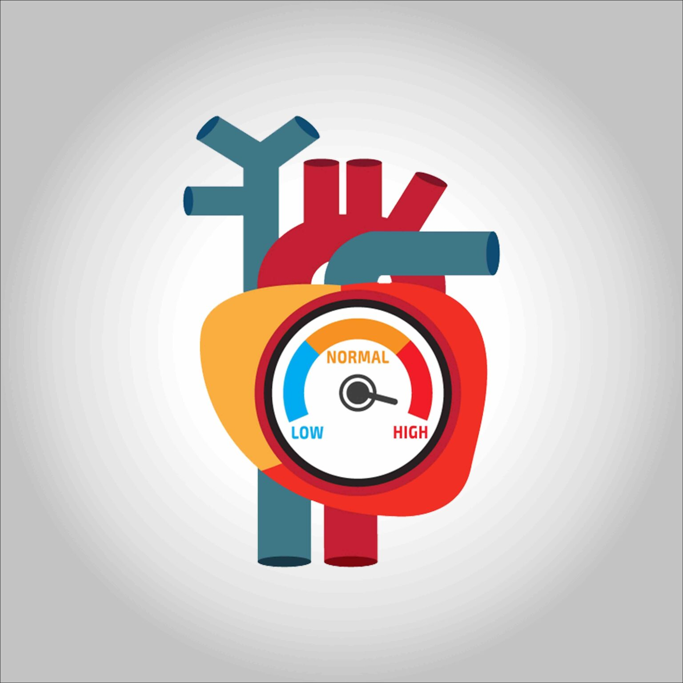

**First, the definition of hypertension**

**Hypertension is described when the force of blood pressure on the walls of the blood vessels is constantly high.**

**How does the circulatory system and blood pressure work?**

**In order for us to live and for the body’s systems to function properly, it must get enough oxygenated blood that the circulatory system carries. This pressure is the result of two forces, the first is known as the systolic pressure, which is the force exerted when blood is pumped out of the heart in the direction of the arteries that are part of the circulatory system, and the second force is known as the diastolic pressure, which is the force resulting from the relaxation of the heart muscles between beats. The blood pressure reading represents the two numbers that express these two forces.**

**Symptoms**

**If you want to know the list of symptoms of high blood pressure, you may be surprised to know that most of the time there may be no symptoms.**

* **The best scientific evidence indicates that symptoms such as headaches and nosebleeds (nosebleeds) do not occur in most cases, except for cases known as (hypertensive crisis) in which the blood pressure reading exceeds high values ​​such as 180-120**
* **If the value of blood pressure is usually high and you suffer from one of the following symptoms:**

1. **Severe headache**
2. **Fatigue and confusion**
3. **Vision problems**
4. **Chest pain**
5. **Difficulty breathing**
6. **Tachycardia**
7. **Cramps**
8. **Sensation of a pounding in the chest, neck or ears, then you should wait for five minutes and repeat the measurement. If the reading continues to be 180-110 or higher, you should call for help.**

**[Text Wrapping Break] There is a group of symptoms that may indicate high blood pressure indirectly, including:**

* **The presence of red spots in the eye (subconjunctival hemorrhage)**
* **It is one of the common issues among patients with high blood pressure and diabetes, but neither of them directly causes it, and only the ophthalmologist can discover the problems of the optic nerve resulting from uncontrolled high blood pressure.**

**Blushing**

* **It occurs as a result of an abnormal widening of the blood vessels that supply the tissues of the face, and redness may occur without a clear cause or as a reaction to some stimuli such as exposure to the sun’s heat or extreme cold, eating spicy food or drinking hot drinks as well as some skin care products. The redness of the face may also occur as a result of exposure to psychological emotions, exposure to hot or cold water, excessive consumption of alcoholic beverages, or exercise, all of which lead to a temporary rise in blood pressure. It is worth noting that the redness of the face may occur in cases of high blood pressure than its normal rates, but high blood pressure is not considered the cause of the redness of the face.**

**vertigo**

* **It may occur as one of the side effects of some high blood pressure medications, but it is not considered a symptom of high blood pressure. But this symptom should not be neglected, especially if it started suddenly, as it represents in this case one of the signs of a risk of stroke, such as loss of balance or neuromuscular coordination or difficulty walking. (High blood pressure is one of the main risk factors for stroke.)**

**Arterial injury**

**Healthy arteries are characterized by softness, flexibility and strength, which helps the blood to flow easily and smoothly on its smooth walls to provide all the vital organs and systems in the body with the food and oxygen needed for them.**

**In cases of high blood pressure, the blood exerts additional pressure on the walls of the blood vessels, which may cause the following:**

* **Damage and narrowing of the arteries.**
* **High blood pressure may cause damage to the cells that make up the lining of the artery walls, allowing fats that enter the body and then the blood flow through fatty foods to be deposited on the damaged artery walls, which eventually lose their elasticity and obstruct the normal flow of blood to the various tissues and organs of the body .**
* **Aneurysm. Over time, the rush of blood inside the damaged arteries under high pressure may cause some parts of the arteries to expand and to form protrusions known as (aneurysm), the danger of which lies in the possibility of them bursting and causing dangerous internal bleeding that may kill a person.**
* **This may happen in any of the arteries of the body, but the increased possibility of infection in the largest and most important arteries of the body, which is known as the aorta.**

**heart muscle damage**

**The heart pumps blood throughout the body, and uncontrolled high blood pressure can cause damage to the heart muscle in several forms, including:**

**Coronary Artery Disease Coronary artery disease occurs when the main blood vessels that supply your heart are damaged or injured. Coronary artery disease is usually caused by cholesterol-containing deposits (plaques) in your coronary arteries and inflammation.**

* **The coronary arteries supply your heart with blood, oxygen and nutrients. Plaque buildup can narrow these arteries, reducing blood flow to your heart. Eventually, reduced blood flow may cause chest pain (angina), shortness of breath or other signs and indicators of coronary artery disease. Complete blockage can cause a heart attack.**

**Enlargement of the left side of the heart, the rise in blood pressure causes the heart to exert more effort to pump blood to all parts of the body, which leads to the**

**enlargement of the left ventricle or its muscle stiffness, which are changes that limit the ability of the ventricle to perform its function in pumping blood to the organs of the body Ultimately, this leads to an increased risk of heart attacks, heart failure, or sudden death.**

**Heart failure, over time causes the stress of the heart muscle caused by high**